A REPORT ON SOCIALNETWORKADS DATABASE

The SocialNetworkAds dataset gives insight into the relationship between social Networks and purchase using the range of people’s age and their estimated salary. This dataset consists of 400 data points(rows) and features 3 informative columns: ‘Age’, ’Estimated Salary’ and ‘purchase’. It shows a concise view of the impact of different factors on the purchase. Below is the first 10 rows of the dataset.

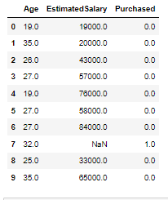

The chart below provides a visualization of the distribution of Social Network, differentiating between age and Estimated salary

**For Age Distribution**: The chart illustrates that the highest concentration of age of those that purchased falls between 35 and 45 units. On the other hand, the lowest concentration age of those that did not purchase falls between 55 and 60 units, showing that people in their prime tend to make more purchase than the younger or aged ones

**For Estimated Salary**: The Chart reveals that people who earned between70-80 units tend to make purchase than those who earned lower or higher which could indicate that those who earned within the -70-80 units range may have more need of what they are purchasing that others

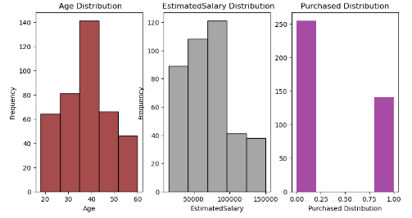

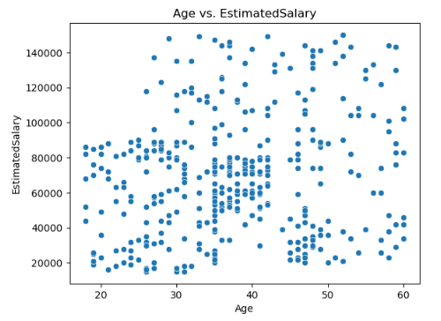

From the chart above, we can see that there is a congestion between units 35 and 45 indicating that, that is the age range and estimated salary range that made the most purchase while the scatter plot between Age vs. sales or Estimated Salary vs. sales is not that pleasing as the correlation does not really make sense.

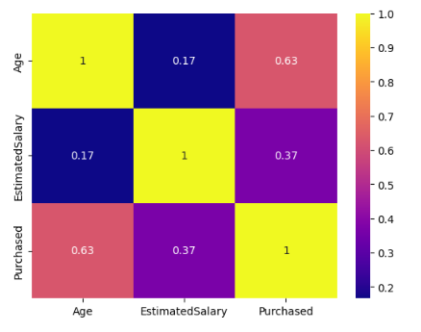

The chart above shows correlation between different variables (Age, estimated salary and Purchase).

Age and Purchase have a strong correlation of approximately 0.63 indicating that as the age increased, purchase also increased significantly.

EstimatedSalary and purchase have a moderate positive correlation of around 0.37, suggesting that there is a moderate positive relationship between EstimatedSalary and purchase.